Registration form

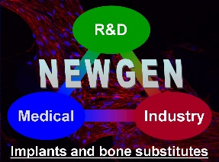

COST Action MP1301 NEWGEN FINAL EVENT

Patient-specific bone tissue engineering

An ambitious goal requiring a „holistic“ approach

in Vienna University of Technology, Vienna, Austria

August 28-29th, 2017

Registration form

Name :
Laboratory - :
Address :
Postcode : |  | City :
E-mail : | @

I wish to attend the NEWGEN Final Event organized in Vienna
even if I am not partially/fully reimbursed by the COST action MP1301 NEWGEN
except if I am not partially/fully reimbursed by the COST action MP1301 NEWGEN

I wish to present a contribution:
Oral
Poster

Title :

Authors:

To be returned before July 3rd 2017

by e-mail to mp1301@bcrc.be

